MDB1032 WRITING PROCESS DIAGRAM ( EXTRA IN-CLASS FOR WEEK 14)
The diagram below shows how coffee is produced and prepared for sale in supermarkets and shops. Write the introduction and body paragraphs to analyze the process using at least 150 words.
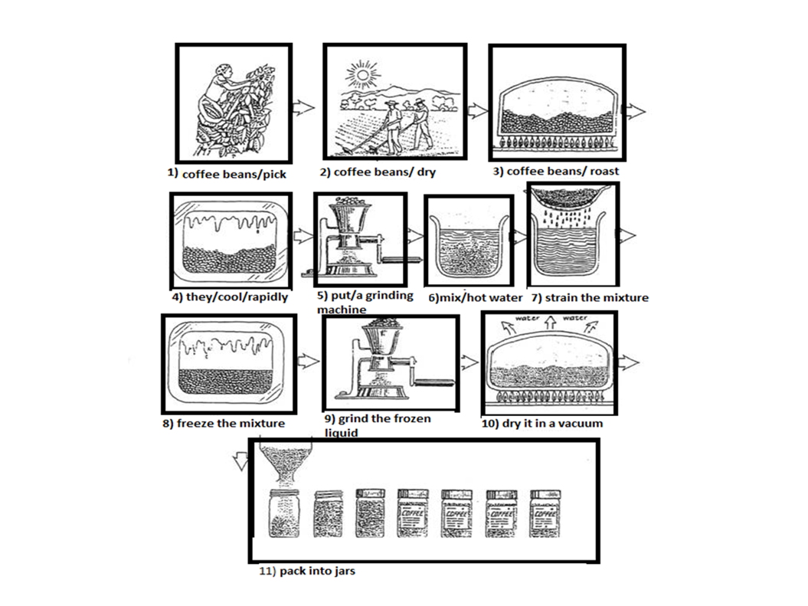
__________________________________________________________________________________________________________________________________________________________________________________________________________________________________________________________________________________________________________________________________________________________________________________________________________________________________________________________________________________________________________________________________________________________________________________________________________________________________________________________________________________________________________________________________________________________________________________________________________________________________________________________________________________

MDB1032 WRITING PROCESS DIAGRAM – SAMPLE ANSWER
The diagram below shows how coffee is produced and prepared for sale in supermarkets and shops. Write the introduction and body paragraphs to analyze the process using at least 150 words.
The picture illustrates the process of coffee manufacture and preparation for sale on the market. It is clear that there are 11 stages in the production of coffee. The process begins with the picking of coffee beans, and ends at the packing stage.
Looking at the coffee production process in detail, coffee beans must first be picked in the fields. These beans are then dried, roasted, and cooled before being put in a grinding machine, which turns the beans into coffee granules.
At the sixth stage in the process, the ground coffee is mixed with hot water, and the resulting mixture is strained. Next, the mixture is frozen and then passed once again through the grinder. After that, the ground, frozen liquid is dried in a vacuum so that the water evaporates, leaving the coffee granules. Finally, these granules are packed into coffee jars for delivery to shops.

