    - Complete the text with the correct form of the verbs in the brackets using Present Simple (Active or Passive), Past Simple (Active or Passive), Present Perfect Simple, Present Perfect Continuous, Past Continuous, and Future.
HAPPY BIRTHDAY, HUBBLE!
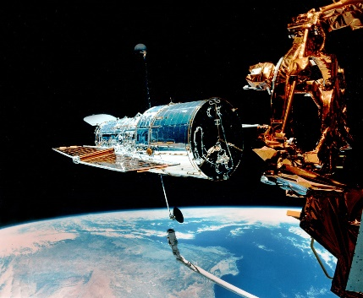
The National Aeronautics and Space Administration, or NASA for short, is celebrating the 25th anniversary of the Hubble Space Telescope this week. The telescope gets its name from American astronomer Edwin Hubble, who 1) ……made…………. (make) breath-taking discoveries about the universe in the 1920s. The telescope 2) …was sent………. (send) into space on April 24, 1990. In the last 25 years, Hubble 3) ………has caught………. (catch) approximately 1 million images from 350 miles above Earth, including pictures of some very far and old galaxies.
Hubble 4) …provides……. (provide) an average of 829 gigabytes of data every month, according to the Institute. Despite this incredible work, Hubble didn’t really have a satisfactory beginning to its career. Soon after the telescope’s launch into space, there was a big problem. While it 5) …was recording……. (record) photographs of a meteor, scientists at NASA found out that its lens didn’t work properly. A few years later, a team of astronauts managed to repair Hubble’s lens. Since then, the telescope 6) …has been taking / has taken…. (take) glamourous images that can be viewed on the official website of NASA.
NASA’s science mission officer, John Grunsfeld, an ex-astronaut who 7) ……flew………. (fly) on the repair mission in 1993, explains that he hasn’t ever flown since his retirement. But he still knows Hubble is working very well. “Hubble 8) will keep / is going to keep………. (keep) working until at least 2020. I’m expecting to witness many surprising discoveries from Hubble before we say goodbye to our telescope,” he says.
    - Choose the correct comparative or superlative forms of the adjectives to complete the text below.

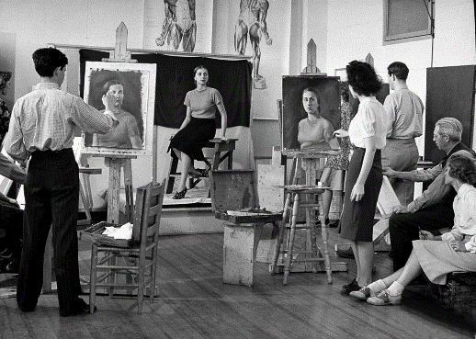
Because I don’t want to feel bored during the two-week semester holiday, I’ve decided to take up painting classes in order to entertain myself. I’ve joined singing classes, creative writing classes, and other various activities before. The first thing I’ve noticed is that, in all of them, the classrooms were quite small. However, the painting classroom is 1) the least big / the biggest / much bigger than I’ve ever seen because obviously, you need lots of space to put the materials inside. This big space is not really necessary in all the other courses. Moreover, for painting, we need a place with good and enough lighting. For this reason, the management of the course has put lights everywhere, and this makes the place 2) brighter than / the brightest of / less bright than the other rooms in the building. Without these lights in our classroom, it would get 3) the least dark / less dark than / darker.

I enjoy attending the classes but there are also certain problems. For one thing, the instructor sometimes does not look so concentrated on her work, and occasionally makes mistakes. Maybe I would like to have a 4) less careful / more careful / least careful instructor so that we could spend an effective time together. Also, she sometimes becomes too strict. I think this doesn’t help students in an art class. Instead, a 5) more strict /the strictest / less strict instructor could motivate me easily. There is one more thing: This painting class is 6) the longest / a little longer / less long class ever! I don’t remember being part of a class for such a long time. But despite these drawbacks, I’m still not complaining. I’m surely learning a lot of techniques and improving myself.
    - Complete the dialogue with the correct forms of the verbs in the brackets using If Conditional Type 1 and Type 2.

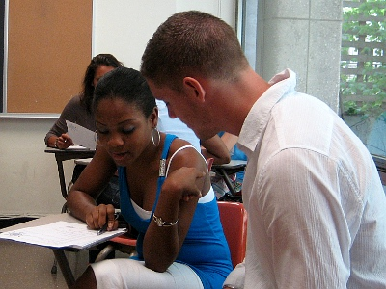
Martin: We have this presentation assignment for next Wednesday’s biology class. OK, where do we start?
Sophie: Let’s talk about the introduction first.
Martin: I suggest including a video to catch the audience’s attention. 1) If people …like………. (like) the beginning of our presentation, then they …will/can/may/might continue……. (continue) listening to the rest of the talk. Without a good introduction, forget it!
Sophie: But listen, you know how our friends are like. They always get bored during presentations. 2) If they …didn’t get ………. (not/get) bored so easily, we …wouldn’t / might not need………. (not/need) to worry about grabbing their attention. But this can only be a dream, I guess!
Martin: Ha ha! There is something else that worries me though. We need to hand in our outlines for the assignment tomorrow. The teacher never accepts late submissions. 3) If he …accepted…………. (accept) late submissions, we …would / could / might have…. (have) a good amount of time to prepare an extensive outline. Unfortunately, it seems that we don’t have the time.
Sophie: Don’t worry about that. I’m free this weekend. 4) If you …send……. (send) the topics to me by e-mail, I …will / can / may / might prepare (prepare) slides with beautiful pictures in them. This should make the teacher happy.
Martin: That’s a good idea. We’ll see what will happen next week.

D. Complete the blanks with the verbs in brackets using present simple (active/passive), past simple (active/passive), past continuous, past perfect simple, present perfect simple, present perfect continuous, and will.
Sir Jonathan Paul Ive is an English designer and the Senior Vice President of Design at Apple. He 1) …has designed…….. (design) many of Apple’s products, including the MacBook, iPad, iPhone and Apple watch so far. He is the second man behind the success of Apple after Steve Jobs.
While he 2) …was studying….. (study) at high school, he 3) …became…….. (become) passionate about cars and this passion 4) …led…….. (lead) to his later career as a designer. After he 5) …graduated / had graduated…….. (graduate) from Northumbria University, he 6) …was hired…….. (hire) by one of the top design agencies in London. In 1992, he started working for Apple and since 1997, he 7) …has worked / has been working.. (work) as the Senior Vice President of Design. This means he is the one responsible for the design of the company’s significant products. By the year 2014, he 8) …had won…….. (win) more than 15 awards and titles in the field of design. During an interview with Time magazine, Jonathan Ive revealed his optimistic view about the future: “This is just the beginning of a remarkable time. I believe, this developing technology 9) …will enable……….. (enable) us to create amazing products that we cannot even think of now. At Apple we 10) are motivated…….. (motivate) by the unlimited potential of technology because there’s always something new to learn and therefore, a new goal to accomplish. That’s why, personally I always feel that I 11) haven’t done.. (not do) my best work yet. In fact, with these rapid advancements in technology, I don’t think I 12) …will be able to…….. (be able to) feel the sense of such accomplishment anytime soon.”

E. Underline the correct answer in the interview about rock climbing.

John: Kate, where do you go rock climbing?
Kate: Wherever there are good cliffs. New Zealand is a perfect place for climbers with its high mountains and it is one of my favourite spots. But I usually go to Switzerland, because it is 1) little / much / a lot of closer to where I live. The cliffs in Switzerland are not 2) the highest / higher / as high as the ones in New Zealand, so it is not a popular place among climbers. In fact, it is one of 3) the least/ less / much more known places in the world. That is why I prefer that spot.
John: Are there a lot of women who do this sport?
Kate: No, mostly men are interested in this sport. There are 4) few women / fewer women than / as few women as men. So, they are opening female only courses to get women into the sport.
John: I guess most people are scared of rock climbing because they think it is a very challenging and dangerous sport. What do you think?
Kate: Well, it is 5) the most dangerous / the least dangerous / as dangerous as any other extreme sport. Actually, any sport, even football, can be risky unless you are careful and well trained.
John: Is it an expensive sport? Do you need any special equipment other than climbing shoes and ropes?
Kate: Not really, it is 6) more expensive / less expensive / a little expensive than many other sports. Apart from shoes and ropes, all you need is a mountain, and mountains are free.
John: Yes, they are indeed! Thank you Kate for this lovely interview.
Kate: You’re welcome, John!

F. Underline the correct answer.
The Internet: Then and Now
The Internet began with a small network of computers in the 1960s in the United States military. Non-military users began enjoying the benefits (1) when / before / by the time companies and American universities were given access to do research related to military projects. In 1989, the World Wide Web (2) presented / was being presented /was presented to the world. Now, this unique tool is available 24/7 (3) as long as / until / before we have electricity or a form of power to get us online. A quick survey reveals that most people use the Internet (4) though / as / yet it’s an easy way to stay in touch with others. As students, we use the Internet to do research and help us with our assignments. We love (5) being / be / to being able to find lots of information and the fact that we can make it ours. Electronic commerce is also one of the fastest growing areas of Internet use. Buying cars, sending musical greeting cards, downloading the newest music, and even trading stocks can be done every day on the Internet before some of us see the sun rise. I think any of us who make the Internet a daily companion would agree that nothing (6) was / has been / will be the same since we first decided to go online.
The Mystery of the Stardust
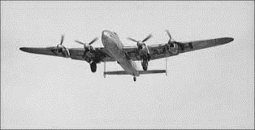
At 5:41 p.m. on August 2, 1947, Dennis Harmer, the radio operator of an airplane called the Stardust, sent a message to the airfield in Santiago, Chile. He said that they (7) would arrive / will arrive / arrived in Santiago at 5:45 p.m. But the Stardust never showed up. Authorities conducted a search in the nearby Andes Mountains for the wreckage but the area was (8) enough / too / little extensive to find signs of the plane. It had completely disappeared until, in January 2000, mountaineers climbing in the Andes found an old airplane engine belonging to the Stardust. Following a thorough search of the area, approximately 10% of the wreckage (9) found / was found / had been found. Authorities studied the plane’s other messages, old weather data, pieces of the plane and the area where the crash happened. (10)Nevertheless, / On the other hand, / Consequently, they were able to reach an explanation. When the Stardust sent its message at 5:41, the pilot thought they were (11) close / closest / closer to Santiago than they really were, and he began to lower the plane. (12) Despite / However, / Although the mountains were still in front of them, and the plane crashed straight into a glacier, causing an avalanche that covered the plane in ice and snow.

G. Complete the text using a, an, the, or x for no article.

Symbols of Power
A Shape: The five-pointed star is very commonly used to symbolize military power, and is used on military vehicles and uniforms in (1)…x…. many countries. It is also (2)…a…. very common national symbol and is used on the flags of 35 countries. For example, there are 50 stars on the flag of the USA, and they represent (3)…the.. states in that country. The symbol for the European Union also includes stars to represent the member nations.
Colors: Light blue is the color of the United Nations. It was chosen because it is the color of the sky above (4)…x…. every nation on Earth. (5)…The…. color is also used as a protective sign on the hats of UN peacekeepers so that they are not mistaken for the enemy. Red and green also have political meaning. Red is (6)…the…. only color associated with socialism and communism, while green is used by parties mainly concerned with (7)…the…. environment.
Animals: Countries often have (8)…an…. animal as a national symbol. Lions and eagles are very popular symbols because they represent (9)…x……. strength. For example, Bulgaria, England, and the Netherlands have the lion as the national animal, and the USA, Mexico, and Austria have various kinds of eagle. Animals which are very characteristic of the region are used in (10)…x……. other countries, such as the kiwi in New Zealand or the springbok antelope in South Africa.

H. Choose the correct option to complete the text.
CHOPSTICKS
Although it is not known exactly when chopsticks first began to be used, it is fairly certain that they were invented in China. According to the records, they date back as far as the third century BC. In ancient times, the Chinese found it difficult to dip vegetables in the soup with spoons. 1) Therefore……, they invented chopsticks and started eating with them instead of spoons. Chopsticks 2) … are made … of materials like bamboo, plastic, wood or steel in general. Silver, porcelain or ivory is 3) less likely to be used as they are costly. Today, 4) … besides … China, chopsticks are used in other countries such as Japan and Korea, but there are several differences. For example, Chinese ones have a blunt end 5) … whereas … in Japan the end is pointed and sharper. Because the use of chopsticks 6) … have been … a part of Chinese food culture for so long, there are some taboos that you 7) … must pay … great attention to, or you may offend your Chinese hosts.
Nowadays, chopsticks serve many functions apart from tableware. For example, you can buy a pair and give it to a newly-married couple as a wedding gift. Chinese people call chopsticks “Kuaizi”, 8) … which … means ‘have sons soon’, so the couple will be very happy to accept this gift. Or you can buy chopsticks as a souvenir, especially the beautifully painted ones like artwork are worth buying.

- a. Also b. Therefore c. On the other hand d. Similarly
- a. have made b. are making c. are made d. will be made
- a. less likely b. more likely c. as likely as d. likely
- a. in addition b. moreover c. besides d. likewise
- a. where b. due to c. despite d. whereas
- a. was b. were c. have been d. has been
- a. might pay b. must pay c. can pay d. could pay
- a. which b. that c. what d. whose

I. Choose the correct option to complete the text.
THE LEGACY OF THE SAMURAI

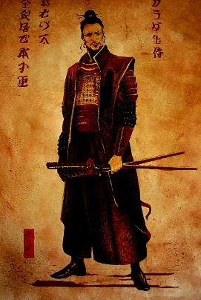
The Samurai (the word means ‘one who serves’) were the elite warrior class of Japan for nearly 700 years. In the tenth century, the Japanese Emperor tried to organise an army but didn’t succeeded in 1) …doing…… so. Because of this, the wealthy landowners hired private soldiers to form their own armies to protect their lands. This led to the birth of the ‘samurai’. If the landowners 2) …hadn’t done… this, the samurai might have never existed... They were specially trained, talented soldiers. They have always been associated with courage and strength. As well as being fearless warriors, the samurai 3) used to socialize… with intellectuals and artists when they had time for cultural activities. Among these activities, the tea ceremony stood out. Interestingly, it was 4) … as significant as … battle training to these warriors. The tea ceremony was a ritual, almost a meditation. It took place in a small room where swords 5) were forbidden…… even to samurai. This peaceful atmosphere 6) … must have been … very relaxing and comforting to the war heroes after long hours or sometimes days of fierce battles. These were glamourous times for the samurai. Unfortunately, during a long period of peace in Japan, things didn’t go well for them and eventually, by the year 1860, they 7) … had already lost… their power in Japanese society.
However, the effects of the samurai on the martial arts tradition 8) …can be observed… even today. In Japan, each spring, men put on samurai costumes and create fake battle scenes to honour the samurai. These “weekend samurai” look realistic but when we asked them 9) … if they had ever dreamed of …… being a samurai, we understood that they all liked the idea and admired these legendary heroes, but they also feared the high possibility of death. In the end, being a samurai takes a lot of courage that many people lack today.

1. a. to doing b. do c. doing d. to do
2. a. didn’t do/would never exist c. did/might exist
b. hadn’t done/might have never existed d. had done/would have existed
3. a. should have socialized b. have socialized c. had socialized d. used to socialize
4. a. as significant as b. more significant c. less significant d. the most significant
5. a. were forbidding b. are forbidden c. were forbidden d. are forbidding
6. a. must be b. can be c. should have been d. must have been
7. a. were already lost c. have already lost
b. had already lost d. have already been lost
8. a. can be observed b. can observe c. must observe d. must be observed
9. a. had they ever dreamed of c. if they have ever dreamed of
b. if they had ever dreamed of d. have they ever dreamed of

J. Choose the correct option to complete the text.
CAMINITO DEL REY

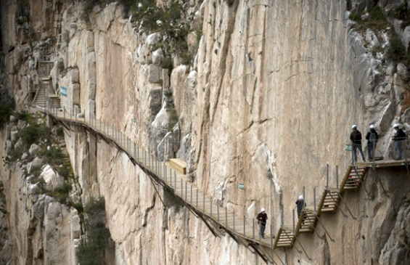
Caminito del Rey is not an ordinary walkway. It is a narrow walkway, 1) …whose… location and dimensions make it one of the deadliest paths in the world. It is 90 cm. wide and hangs 30 m. above the Guadalhorce River in Malaga, Spain. The path has been partially closed since 2001. The authorities decided to shut the entrances after five people died in less than two years while they 2) … were attempting …… to cross the path. These deaths made it obvious that the path was 3) not safe enough … for the people to cross.
The path underwent years of repair work and now it is ready to meet the new adventure seekers with its new safety features at the beginning of June. The authorities had the walkway 4) …renewed…… with safety lines and steel bolts. They also have new regulations for visitors now. Only groups of fifty people can enter the walkway every half an hour and these people 5) … won’t be allowed … to enter unless they wear a helmet.
The reopening is of huge importance to 6) …the… local area. It may not be the world’s scariest hike anymore but Caminito del Rey’s true attraction is still there. Now, more people would like to go to Malaga not only for its beautiful beaches but also for the special experience of walking on a safer 110-year-old walkway. Entrance 7) … is going to be … free during the first six months and if you hurry you can be one of the lucky visitors to see this magnificent place free of charge.

1. a. when b. where c. which d. whose
2. a. were attempting b. are attempting c. had attempted d. have been attempting
3. a. not enough safe b. too safe c. not safe enough d. not too much safe
4. a. to renew b. renewed c. renewing d. renew
5. a. will allow b. won’t allow c. will be allowed d. won’t be allowed
6. a. the b. a c. --- d. some
7. a. was b. is going to be c. has been d. had been

K. Choose the correct option to complete the text.
MOBILE FITNESS APPS CHANGE THE GAME
Too lazy to go to the fitness studio 3 days a week? Or perhaps you do not want to pay so much for a 1-year gym membership. The answer might be the mobile apps that provide flexible options. These new apps let users 1) …book… fitness classes on a per-session basis, rather than sign up for full membership. And when you decide not to continue, these classes 2) …can be cancelled… at any time. Therefore, there is no stress when you want to cancel. Especially those gym-haters that don’t fancy visiting the gym after a tiring work day can enjoy the benefits of these apps without leaving their home. Fitness expert Laura Williams is watching the increase in the popularity of fitness apps. “I 3) …haven’t found… an app yet, which is as comprehensive as I want. But they are certainly on the right track,” she says.
ClassPass, Book Your Game, or MoveGB are popular examples of such fitness apps. The important thing is that they should offer a wide variety of alternatives to customers. 4) …Unless…… an app comes with enough options, it may start losing customers. For example, the founder and chief executive of ClassPass, 5) …whose… aim is to give gym-goers the opportunity to create a flexible fitness schedule, says they want to remove the barriers to doing fitness. They are trying to make people 6) …love… the gym.
7) ……While… ClassPass has successfully attracted many people to use the app so far, not all of them have been so lucky. The apps that do not offer good options to customers have been 8) …less successful than…… examples like ClassPass. Therefore, not earning from this new trend, they are leaving the platform.
- a. book b. to book c. booked d. booking
- a. couldn’t be cancelled b. must be cancelled c. can be cancelled d. shouldn’t be cancelled
- a. haven’t been finding b. haven’t found c. am not going to find d. wasn’t finding
- a. Unless b. If c. Whenever d. Since
- a. when b. that c. which d. whose
- a. to love b. love c. loved d. to loving
- a. Until b. As soon as c. While d. In spite of
- a. less successful than b. as successful as c. more successful than d. the most successful

L. Choose the correct option to complete the text.
INSIDE THE STUDIO OF JOAN MIRÓ
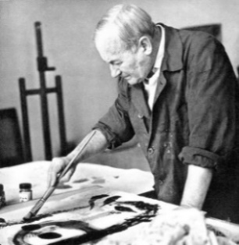
In Majorca, Joan Punyet Miró is standing inside a studio. His grandfather, the famous Spanish artist Joan Miró worked here from the late ‘50s almost until his death in 1983. The paintings created in this studio had a great influence 1) …on… the younger generation of painters after the Second World War. The grandson Miró remembers 2) watching… his grandfather as he mixed paints in this studio. “3) …Although…… my grandfather was a big fan of music, he insisted on having silence and played no music at all during his working hours,” he explains. “And most of the time, he 4) didn’t want… his grandchildren to play nearby while he …was painting… .”
Miró had quite strict working habits. He 5) …used to……… wake up at 7am. The first thing was studio work from 9am to 2pm, and then after lunch and a siesta, answering letters would follow. Miró’s grandson thinks if Miró 6) …hadn’t lived……… such a strict life, he …might not have produced… so many beautiful works of art.
He was also a man of risks. One day, the gallery owner that worked with Miró came to visit him. “But Miró, your new paintings are 7) …too……… radical and, for me, risky to exhibit. How am I going to sell them?” he said. Miró replied: “Don’t worry – wait 35 years and you sell them then.” And the gallery owner said: “I 8) …will be……… dead by then!” Miró was right.
According to Joan Punyet, people have false ideas about his grandfather’s moving to Majorca during World War II. “He wasn’t the type of person that would be afraid of death. So he 9) …couldn’t have come…… to Majorca because of fear of death. The only thing he feared was repeating himself.”
1. a. with b. on c. against d. at
2. a. watch b. to watching c. to watch d. watching
3. a. Since b. Despite c. Consequently d. Although
4. a. didn’t want/was painting b. wasn’t wanting/was painting
c. didn’t want/is painting d. hadn’t wanted/has painted
5. a. must b. should c. used to d. didn’t have to
6. a. didn’t live/might not produce b. might not have lived/hadn’t produced
c. hadn’t lived/might not have produced d. had lived/might have produced
7. a. enough b. too c. too much d. little
8. a. have been b. were c. will be d. had been
9. a. shouldn’t have come b. must have come c. may have come d. couldn’t have come

M. Choose the correct option to complete the text.
THROUGH THE FOREST
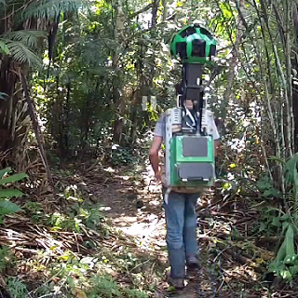
For its next technological trick, Google will show you how to go deep into the Amazon jungle. This week, the company has added images of the rainforest to its ‘Street view’ service. Up to now, most of the images have been taken in city centres by cameras on top of cars easily 1) whereas.. in places with no roads, like the Amazon, cars have not been a possible option to photograph the environment. But for Google, taking photographs in the wild was something new, and they needed help from certain organizations. 2) …Thus.. , the company worked with an environmental protection group to explore parts of the forest that are difficult to reach. The group has given Google valuable advice, too, like how to be cautious 3) …about.. the environment while walking around the trees. The workers in the protection group helped Google develop the ‘Trekker Camera’ to go down to the rainforest. Since Google 4) …built….. this device, it has also been used in places other than the Amazon, 5) such as….. the Grand Canyon, the Galapagos Islands or the Canadian Arctic.
“When people approach us with crazy ideas, we always show interest. The workers of the protection group came to us with the crazy idea of ‘Trekker Cameras’ at the beginning of this project,” said Karin Tuxen-Bettman, who manages Google’s Street View partnerships. “If these workers 6) hadn’t come.. with this project for the Amazon, we …might not have been so brave to go into the Amazon because they know more about the area than us. I’m sure we will work together on new projects again in the future 7) …in order to.. take photographs of other unknown places near the Amazon region. We want to know 8) if there are….. still undiscovered and exotic places to discover in the world.”
1. a. whereas b. until c. likewise d. consequently
2. a. However b. Thus c. All in all d. Yet
3. a. against b. through c. about d. above
4. a. had built b. built c. has built d. is building
5. a. due to b. despite c. so that d. such as
6. a. didn’t come/might not be b. hadn’t come/could have been
c. hadn’t come/might not have been d. wouldn’t have come/hadn’t been
7. a. in order to b. for c. because of d. in spite of
8. a. if are there b. what there are c. that there are d. if there are

N. Find the sentences which is in the closest meaning to the given one.
- In the absence of the director only her assistant can sign the contracts.
- When the director is out of town contracts are assessed by ther assistant.
- When the director can’t be reached her assistant usually has the power to sign the contracts.
- Whenever the director goes away, no one but her assistant is authorized to sign the contracts.
- Once the director has left, it might be her assistant to sign the contracts.

- For reasons of hygiene, it’s forbidden to try on the earrings in the jewellery department.
- Because it is not hygienic, customers in the jewellery department are not allowed to try on the earrings.
- Customers who care for hygiene are advised in the jewellery department not to try on any earrings.
- Earrings are considered unhygienic and so forbidden for sale in this jewellery department.
- The jewellery department accepts no responsibility for earrings damaged by customers.

- It’s no use talking to her because she’ll do as she pleases whatever we say.
- She only listens to you, so I don’t bother talking to her any more.
- We’ve told her it’s not important , and we don’t need to say anything more about it.
- She only cares about herself and never talks to either of us.
- Nothing we can say will make her change her ways, so it’s pointless for us to say anything.

- My sister has just arrived, so she still doesn’t know what’s happened.
- It’s a long time since my sister came, so she doesn’t know what’s been happening.
- My sister hasn’t been here long, so nobody thought the news would interest her.
- As my sister only got here a minute or two ago, she hasn’t heard the news yet.
- If my sister didn’t arrive a little earlier, she wouldn’t have been given all the news.

- “I’m afraid we haven’t received the results of your tests yet,” said the doctor to her patient.
- The doctor told her patient not to be frightened of receiving the results of his tests.
- The doctor apologized to her patient for not having received the results of his tests yet.
- The doctor said she was afraid of receiving the results of her patient’s tests.
- The patient understood that the doctor had some fears about getting the results of his tests.

6. Due to the fact that the demand for tea was very high in the 19th century, its price was astronomical.
a. It was not until the 19th century that the demand for tea started to increase.
b. The demand for tea was so high in the 19th century that its price was enormous.
c. In the 19th century the price for tea didn't increase despite the demand.
d. It was its astronomical price which decreased the demand for tea in the 19th century.

7. After failing a doping test at the Seoul Olympics, Ben Johnson was stripped of his gold medal.
a. At the Seoul Olympics Ben Johnson and many others were disqualified after failing a doping test.
b. If Ben Johnson hadn't been tested positive for doping at the Seoul Olympics, he wouldn't have lost his gold medal.
c. Since Ben Johnson confessed having used doping his gold medal was taken back.
d. As Ben Johnson failed the doping test again at the Seoul Olympics, he was stripped of his gold medal.
8. How about booking in advance to eat at Phil’s restaurant at the weekend?
- Do we need to book in advance to eat at Phil’s restaurant at the weekend?
- Why don’t we book in advance to eat at Phil’s restaurant at the weekend?
- Are we allowed to book in advance to eat at Phil’s restaurant at the weekend?
- Would you mind eating at Phil’s restaurant at the weekend without booking in advance?

9. English is spoken by the largest group of people after Chinese.
- English comes second after Chinese as the most spoken language in the world.
- The Chinese speak mostly English, only after their own language.
- The largest group of people in the world is the Chinese and they speak English.
- The Chinese language is not spoken as much as English in the world.

10. We must remember what happened in the past so that it will never happen again.
a. If we could remember the past, it would not happen again.
b. Since we all tend to forget what happened in the past we do the same mistakes again.
c. We couldn't remember what happened in the past so we did it again.
d. In order not to repeat the past, we should certainly not forget what happened then .

O. Find the sentences that complete each paragraph.
- ___________________ . In the past, every neighbourhood had a little food market. Now, every neighbourhood has a big supermarket. These are very different places. The old markets were usually small and friendly. People from the neighbourhood often went there to hear the news or to talk. However, this is not true in today’s supermarkets. Supermarkets are usually large and not friendly. They are not good places for meeting friends or talking. Many people in supermarkets seem to be tired and in a hurry. Often they are not very polite.

- People are in need of new supermarkets.
- Shopping for food in the United States today is not the same as it used to be.
- You can not see any little food markets in big cities.
- Shopping in the supermarket has negative effects on society.

- People are interested in househusbands these days. _________________. On the other hand in my opinion, these are the easiest things to learn. It was much harder for me to change the way I think and the way I act with my family. I think other men will also find this harder, but, like me, will find it necesarry if they want to have a happy family.

- Househusbands have to change the way they live.
- They think househusbands are beneficial for the family unit.
- Househusbands cannot be in a hurry all the time.
- Usually they talk about men doing the housework, the cooking, cleaning and shopping.

- There are many different causes for car accidents in the United States. Sometimes, accidents are caused by bad weather. _____________. Accidents can also result from problems with the car. Even a small problem like a flat tire can be serious. Bad roads are another cause of accidents. Some accidents happen because the driver falls asleep. Finally, some accidents are caused by drinking alcohol. In fact, this one of the most important causes of accidents.

- The weather is always changeable in the U.S.
- Using public transport might be more comfortable during the rush hour.
- For example, ice or snow can make roads dangerous.
- There are a lot of cars on the road, especially in the West of the city.

- _____________. There is example and obvious relationship between the rise in economic wealth and general improvements in our life styles. The degree of the relationship between social and economic change means that many organisations are influenced by changes in society.

- The nature of family life is constantly changing.
- Most forms of social change are related to economic change.
- New economic policies adopted by the government give priority to economic growth.
- Population increase has a damaging effect on economic recovery.

- Strangely enough, Leonardo da Vinci hated to delegate work to others and would only do so an extreme emergency. ____________ ; and certainly no artist of his age became known
from Vinci’s studio.

- His assistants, moreover, were all exceptionally skillful.
- As a result he has been accused of not passing on this artistic skill to others.
- Therefore many of his works had to be finished by his assistants.
- Naturally he was not willing to do much of the purely manual work himself.

- People from abroad visit Cappadocia for different reasons. Mainly they come for the exotic scenery and the archaelogical interests. _______________. Moreover, in the region, there are many places of remarkable beauty and historical significance.

- The rock monastries in particular attract large crowds’ attention
- It is only recently that the number of tourist in Cappadocia has decreased.
- Few people had realized that Cappadocia could be developed as a tourist center.
- The majority of tourists in Turkey prefer sea-side resorts.

- A child learning to speak notices a thousand times a day the difference between the language he uses and the actual use of language around him. _____________. In the same way, a child learns to do all other things without being taught to walk, run, jump by comparing his own performance with those of more skilled people and making the necessary changings slowly.

- Children learn what an educated person must learn one day.
- Bit by bit, he makes necessary changes to make his language like other people’s
- Schools provide a basis for the children to learn new things
- It won’t be possible for a child to produce complex sentences.

- One of the most popular newspapers, The Times, has three weekly supplements all published and sold seperately. These are The Times Literary Supplements, The Times Education Supplement and The Times Higher Education Supplement. ______________. It is devoted almost entirely to book reviews and covers all kinds of new literary studies.

- Obviously they affect the way people think to a considerable extent.
- Both of these appeal only to a restricted number of people.
- The Literary Supplement has the biggest number of audience among these.
- They make good use of academic studies on issues related to education and literature.

- Some parents are concerned about the quality of the education their children are receiving. ______________. For example, according to a study which was conducted a short time ago, the number of high school students who cannot read properly is increasing, and so are the number of the students who have difficulty with simple mathematics.

- However, not all of these people are worried about the same things.
- Almost 9% could not find the city they live on a map.
- Young people often watch six hours of television a day.
- They claim that their children are not learning enough in school and some researchers agree with them.

- In Britain, it used to be the responsibility of the municipalities to provide gas and electricity for public use. However, this was changed by the Attle government; _____________. Steel, coal and railways were the examples of these.

- they were extremely interested in unemployment and economic decline.
- the policy they followed was bound to make them unpopular
- there was naturally a great deal of reaction from the public
- all gas and electricity services were nationalized as well as several other industries.

