**YILDIZ TECHNICAL UNIVERSITY**

**SCHOOL OF FOREIGN LANGUAGES**

**2016 - 2017 FALL, WEEK 10**

**WEEKEND ASSIGNMENT 2**

**(C Level)**

**Guessing the meaning of unknown words using contextual clues**

Like all good readers, you can develop strategies and use clues (information that helps you solve a problem) to help you figure out the meanings of words you do not know. One strategy you can use is to guess the meaning using the context (the words and sentences around the word). This is an important skill to develop because you don’t have to keep stopping to look up unfamiliar words in the dictionary. You can then read more quickly, which makes it easier to remember and understand what you are reading. Some are given in the following table with examples.

|  |  |  |
| --- | --- | --- |
|  | **Contextual Clues** | **Examples** |
| **Punctuation** | commas **,,,**  parenthesis **( )**  colons **:**  dashes **-** | 1. Metrology**,** the science of measurements**,** is based on precision. 2. A prevalent **(**widespread, common**)** attitude is one of caring only for oneself. 3. There has been a sudden rise in the cost of utilities**:** water, gas and electricity |
| **Definition** | X can be described as  X is / are (called)  X can be defined as  X is also known as  X refers to/involves/means | 1. Fatigue can be generally described as the tiredness and exhaustion that result from muscular work. 2. Segregation refers to the setting apart of one group from another. 3. Drug abuse means becoming dependent on drugs. |
| **Contrast** | while, whereas, but, yet, unlike, however, on the contrary, on the other hand, although,… | 1. While deserts are expanding, forests are shrinking. 2. He is not stingy. On the contrary, he is quite generous. 3. Some actions are learnt, but others are inborn. 4. Although they look similar, these plants are actually quite distinct. |
| **Comparison** | similarly, both, likewise, just as | 1. She was late, and I similarly delayed. 2. He didn’t attend his math classes very regularly; likewise, he was reported for excessive absences in his chemistry class. |
| **Examplification** | such as, such, like, e.g., for example, for instance,  to illustrate | 1. In the markets, basic commodities such as meat, sugar and cooking oil are often available. 2. Meral is generous; to illustrate / for example, she volunteers her time and gives money to charities. |
| **Reformulation & Explanation** | i.e.  in other words  that is  that is to say  namely | 1. I am not sure that his business is legitimate, i.e. is   legal.   1. Most human beings are omnivores; that is they eat   both animals and plants. |
| **Synonyms & Antonyms** | Synonyms and antonyms may also be accompanied by conjunctions: “or”, “neither… nor”, “both … and” | 1. To repeat one small job hour after hour is both tedious and boring. 2. The boss neither confirmed nor denied the news. 3. The velocity or speed of light is about 300.000 km per second. |

**Practice 1**

**Guess the meaning of the bold words in the following sentences using contextual clues present in the sentences.**

1. When Marcus entered the class, he felt calm. However, as soon as he opened the test paper, he began

to feel **agitated**.

1. very nervous b) angry c) peaceful d) confused
2. Journalists must be **versatile**. For example, they must be good at writing, listening to people, speaking,

working quickly and doing research.

1. able to do one thing c) able to communicate well
2. able to do lots of different things d) better at one skill than another
3. When James worked in the office, his job was **sedentary**. In contrast, when he became a reporter he

was almost always away from his desk.

1. well paid b) sitting a lot c) moving around a lot d) exciting
2. The national report said that most of the **illiterate** citizens, those who cannot read or write, live outside

of the main cities.

1. unable to read or write b) poor c) rich d) not very good in school
2. Rising prices will have serious **consequences**. Many people, for example, may not be able to buy

enough food this winter.

1. possibilities b) causes c) discussions d**)** results
2. **Philanthropists** such as Bill Gates and Warren Buffed are usually very rich people who give away large

amounts of money to improve things like health and education.

1. business people who love making money c) people who know a lot about computers
2. people who don’t like to spend money d) rich people who spend their money to make

life better for others

1. My father is a real **shutterbug**: wherever he goes, he carries around his camera and takes pictures of all

kinds of things he sees.

**shutterbug** means _______________________

1. People living in dirty places are more likely to catch infectious diseases; therefore preventive health care

units emphasize the spread of **sanitation**, or hygiene, throughout the country.

**sanitation** means ________________________

1. Close friends are always ready to listen to one’s problems. In **superficial** friendships, however, such

supporting and sharing may not be possible.

**superficial** means _______________________

1. The criminal was **convicted** to ten years, but he was released after five years because of good behaviour.

**convicted** means _______________________

1. Unlike her **gregarious** sister, Jane is a shy, unsociable person who doesn’t like to go to parties or to make new friends.

**gregarious** means _______________________

1. George is no longer **novice** at the computer. Though he has only been using it for a short time, he can already use many of the programs.

**novice** means __________________________

1. Suzanne’s teachers were very **succinct** in their report to her parents. They had simply written. “A model student.

**succinct** means _____________________

1. As a student, Cem had very little money, so he had to be very **frugal** with his spending.

**frugal** means _______________________

1. The news story was based on a letter that was a **fabrication**. Now the reporter who wrote the story is in big trouble. Will anyone believe him again?

**fabrication** means ___________________

1. Some people believe that lawyers always work to see that justice is done. On the other hand, some believe that lawyers only want to **manipulate** the legal system to get what they want. Could both sides be right?

**manipulate** means _____________________



**Practice 2**

**Skim the text and give short answers to the following questions.**

**YAWNING**

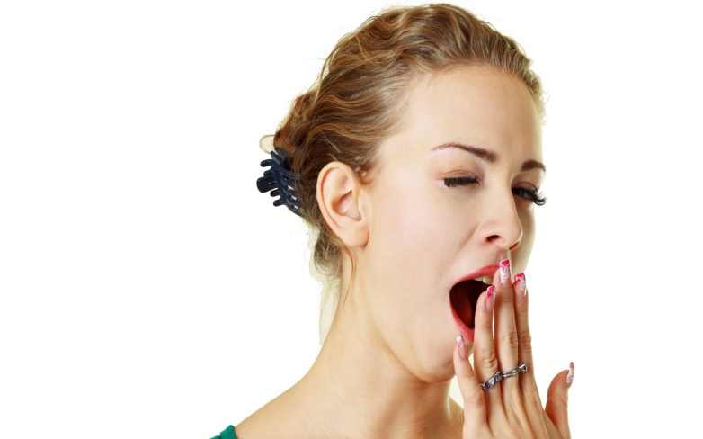A yawn does not mean that you are bored or tired but just the opposite! It means your body needs more oxygen. Most people think that a yawn signals sleep but it actually makes the body ready for action. Studies show that we yawn before a big event- athletes yawn before a race, pilots yawn before take-off and students yawn before an exam. Why, then, do we yawn before bedtime? Most probably our body wants a change, enough of TV, it is time to go to bed!

Most people do not remember their first yawn. Although yawning is contagious- if you see someone with his mouth open, you too will do the same thing- children do not begin to copy other people’s yawns until the age of four. They need time to learn to copy their parents’ behaviour and studies show that quick learners start yawning earlier.

1. What is Paragraph 1 about?

________________________________________

1. Which words helped you determine the content of the paragraph?

________________________________________

1. What is Paragraph 2 about?

________________________________________

1. Which words helped you determine the content of the paragraph?

________________________________________

1. The text is for ___.

a) professionals

b) university students

c) parents

d) the public

**Practice 3**

**THE GLOBAL VILLAGE FINALLY ARRIVES**

This is a typical day of a typical person in today’s world. I wake up to the sound of my Japanese clock radio and put on a T-shirt from Nigeria, jeans from Italy. My breakfast coffee is from South America. I walk out into the street, past German cars, there are English-language students from Korea, Switzerland, and Argentina around me. For lunch I usually eat Mexican food, then go to a Thai café. Who am I? I sometimes wonder. And where am I?

I am the son of Indian parents. I am a British citizen and spent much of my time in Japan. Now I am in Southern California, but I could as easily be in Vancouver or Sydney or London or Hong Kong. The whole planet is going global. More and more of the globe looks like America, but America itself is looking more and more like the rest of the globe. A common multiculturalism links us all. *Taxi, hotel, disco, yoga, pizza* are **universal** terms now.

News, clothing, food and even languages are moving across borders in the **diversified** world of the twenty-first century. But not only these things are mixing. In Brussels, one new baby in every four is Arab. In Japan, **rub shoulders with** Iranians, British, Pakistanis and Filipinos. When people move around the globe, cultural values go with them. New immigrants from Taiwan, Vietnam, and India **import** values of hard work and family closeness to America, while at the same time America sends its individualism to Taipei, Mumbai, and some other Asian countries.

Today, all cultures are crossing at the speed of light and making their way to sleepy villages on all the continents of the world. Although it is exciting, there are dangers in this globalization. Some traditions and customs are changing or they are lost. Also, the world may become even more **divided**, into the “haves” and the “have nots”. Today, as I eat my sushi in California, I wonder about my future in this global village.

1. **Scan the text and mark the following statements True (T), False (F) or Not Given (NG).**

|  |  |  |  |  |
| --- | --- | --- | --- | --- |
| **Q** | **STATEMENT** | **TRUE** | **FALSE** | **NOT GIVEN** |
| **1** | The author is an unusual person, living in a strange city. |  |  |  |
| **2** | The global culture is American. |  |  |  |
| **3** | American values are taking over the world. |  |  |  |
| **4** | Adults don’t want to live in global village. |  |  |  |
| **5** | There are many Arab people live in Brussels. |  |  |  |
| **6** | When people move around the globe, so do American values. |  |  |  |
| **7** | Immigrants from Asia care about their family relations. |  |  |  |
| **8** | Globalization is happening very slowly. |  |  |  |
| **9** | Asian countries are developing due to globalization. |  |  |  |
| **10** | Globalization may have some bad effects. |  |  |  |

1. **What is the main idea of the whole text?**
2. There is a new agreement among countries to be a global village.
3. Global village is a place where cultures and customs flow across borders.
4. Global village is a dangerous place for young people.
5. Global village will help companies to sell their products.
6. **Match the words with their meanings.**

**1.**universal  a) bring in

**2.**diversified b) associate, connect with

**3.**rub shoulders with c) separated

**4.**import d) common

**5.**divided e) given a variety of difference