ILDIZ TECHNICAL UNIVERSITY
SCHOOL OF FOREIGN LANGUAGES
2016 - 2017 FALL, WEEK 14

WEEKEND ASSIGNMENT 3
(A&B Level)

LIFE IN THE LARGEST CITY ON EARTH

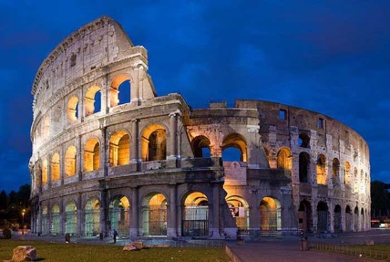
According to some experts, Rome became the first city in the world with a population over 1 million, around the year 100 AD. So, what was life like in the largest city on earth?

Poor people lived in blocks of flats called insulae, sometimes more than three stories high. These flats had no heating, and no running water, so they were not very comfortable. Each flat only had one room. The typical home or domus for wealthier people was the town house. These houses usually had a courtyard or atrium in the middle, as well as bedrooms, a living room, a dining room, and a kitchen. The wealthiest people even had baths or libraries in their houses. People usually painted their houses white at the top, and red at the bottom.

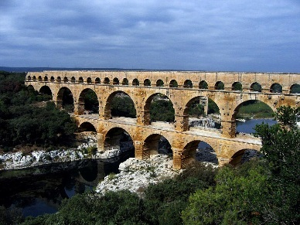
Romans usually ate three times a day. They had a very small breakfast, sometimes only a slice of bread with milk or wine. They had a small lunch. The most important meal of the day was dinner. Many poor people only had bread with some vegetables. Rich people often had dinner parties, with three-course meals. They had meat, fish, vegetables, fruit and sweet desserts. They made their desserts with honey because there was no sugar in those days. They drank wine with water. But everybody in Rome, both rich and poor, used their hands to eat.

Streets in Rome were always busy, with a lot of people walking to work to do business in the forum, which was the main square of a town or city. People also went shopping, visiting the different shops along the streets. There were also colourful markets, temples, and public baths in the city. Rome had amazing architecture, which people still copy today!

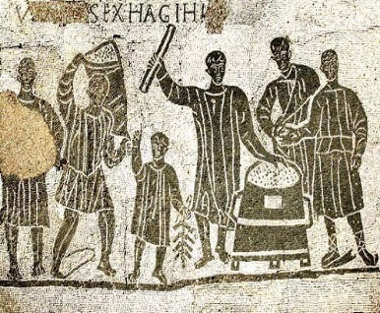
In their free time, Romans went to see chariot races and gladiator fights at the amphitheatre. The most famous amphitheatres in the city were the Circus Maximus and the Colosseum. People also often visited the theatre. Men played all the roles on stage – even the parts of women. The theatre was free for all Roman citizens!

Public baths were also popular – they were like fitness centres or gyms today. Men, women and children all visited the baths. Many baths had restaurants, shops, libraries or museums inside. People could spend a whole day in a bath.

2000 years ago Rome was at the centre of the Roman Empire, and its people enjoyed city life in a similar way to ourselves. Of course there is still a lot we can see of the ancient city today – since Rome is now the busy and beautiful capital city of Italy!

- Read the article. Give short answers to the questions.

- Which was the largest city on earth in the year100AD?
______________________________________________________________ .

- How many people lived in Rome in 100 AD?
______________________________________________________________ .

- What colour were the houses in Rome?
______________________________________________________________ .

- How many times did people eat a day?
______________________________________________________________ .

- What was the name for the main square?
______________________________________________________________ .

- What were the names of some important amphitheatres?
______________________________________________________________ .

- Read the article again. Write true (T) or false (F). If there is no information in the text about the statement, write no information (N).

Q | STATEMENT | TRUE | FALSE | NOT GIVEN
0 | Romans all lived in comfortable homes with heating and water. |  | x
1 | Poor people lived in one-room flats.
2 | Some rich people could have a bath in their own houses.
3 | In the country Roman people lived in farmhouses called villa rustica.
4 | The biggest meal of the day was lunch.
5 | Romans never used sugar in their food.
6 | Roman people always ate with their hands.
7 | The Colosseum is the best example of Roman architecture.
8 | Women had to pay to go to the theatre.
9 | You could do your shopping in some of the public baths.
10 | According to the text, life in ancient Rome was quite different to modern city life.

DICTIONARY DEFINITIONS

SAME WORD; DIFFERENT MEANING

In English, some words may have more than one meaning. That is, when you look up the dictionary, you may find different meanings of a word. To understand the exact meaning of a word, you should look at the context (the words or sentences that come just before and after a word and that help you understand its meaning) and the part of speech-noun, verb, adjective, adverb try to guess the right meaning.

PART A. Read the definitions of the word and choose the correct meaning in the given sentence.

develop 1) (v.) to change, grow or improve, or to make something grow, change or improve.
As the economy develops, social change took place.

2) (v.) to treat a film with chemicals in order to make photographs.
Did you get the pictures developed?

3) (v.) to create a new product or method.
We developed new communications software.

- All children develop at different rates. ( ……. )
- At last, I developed the photos. ( …….. )
- Scientists are developing new drugs to treat cancer. ( ……. )

iron 1) (n.) hard heavy metal that is used for making steel.
iron gates

2) (n.) heated object that you push across clothes in order to make them smooth.
My mother always complains about the iron.

3) (n.) element which is found in very small quantities in certain foods and in the blood.
iron pills

4. (v.) to push an iron across clothes in order to make them smooth
She ironed her blouse.

- “You should follow a diet high in iron” said the doctor. ( …….. )
- Do not keep the iron switched on when you finish ironing. ( ……. )
- Iron is the element that is known by the symbol Fe. ( ……. )

support 1) (v.) to like a particular sports team and always want them to win
I support Manchester United.-Which team do you support?

2) (v.) to help someone and be kind to them when they are in a difficult situation
A good friend always supports his/her friend.

3) (v.) to show that an idea, statement, theory etc. is true or correct
Our conclusions are supported by an expensive research.

4) (n.) money that is provided to a person or organization in order to help them
financial support for the Olympic games

- When my girlfriend left me, Ali supported me a lot. ( …….. )
- The scientific studies supported our theories on that subject. ( …….. )
- Her father provided some support during her financial problems. ( …….. )
- That’s a good coincidence! You and I support the same team. ( …….. )

center 1) (n.) the part of town or city that contains most of the shops, restaurants, and places of entertainment
We caught a bus in to the centre.

2) (n.) a building or group of buildings that is used for a particular activity or providing a particular service
A health centre/ shopping centre

3) (n.) the middle of a space or area
chocolates with soft centres / in the centre of the room.

- Many people go to sports centres in our town. ( …….. )
- The cost of land in the centre of the city is quite high. ( …….. )
- There was a huge brown wooden table in the centre of the room. ( …….. )

PART B. Read the examples. Match each to a sentence a, b or c.

hit : 1. The robbers hit him over the head with a baseball bat.
2. Our profits have already hit $1 million.
3. I bought a CD of the Beatles' greatest hits.

- The price of oil hit a record high of $136 a barrel recently.
- "Titanic" was a big hit all over the world.
- Two boys hit each other with the hammer and one of them had a big scar on his head.

match: 1. It's our last match of the season.
2. I need a box of matches.
3. Your socks don’t match.
4. Few cities in Europe can match the cultural richness of Berlin.

- You can’t match the Turks for their hospitality!
- I can't find anything to match my green shirt.
- Eric scored the only goal in the match against Albany.
- Excuse me, do you have a match?
ring: 1. She is wearing a diamond ring.
2. They danced in a ring.
3. I rang the doorbell but no one came.
4. I was going to ring you but I don't have your number.

- All the students were out of their seats as soon as the bell rang.
- They make great onion rings there; they are so delicious!
- Can you ring me when you get there so I know you are safe?
- The wedding rings were made of silver and gold and tied together with a red ribbon.

PART C. Below are some exercises with words which have more than one meaning.

- LIKE

- (v.) ( not in the continuous tenses ) to find somebody or something pleasant; to be fond of somebody or something.
He is nice. I like him a lot. The opposite is dislike.

b) (v.) to want
How do you like your steak done sir?

Would like is a more polite way to say ‘want’.
Would you like to come to lunch on Sunday?

- (prep.) similar to somebody or something
He looks like his father. Their car is like ours.

showing what is usual or typical for somebody
It was just like him to be late.

in the same way or manner as somebody or something
Stop behaving like kids.

for example
They enjoy most team games, like football and baseball.

d) (conj.) in the same way or manner as
She can’t draw like her sister can.

(informal) as if
She acts like she’s the boss. I felt like I was going to die.

What does the word like mean in these questions? Match each word to the dictionary definition “a”, “b”, “c” or “d” above. Circle your answer.

STATEMENT
1 | Do you like potatoes? | a | b | c | d
2 | Who do you look more like – your mother or father? | a | b | c | d
3 | Would you like to try a dangerous sport like skydiving? | a | b | c | d
4 | What does your best friend like to do? | a | b | c | d
5 | Do you have an older sister who acts like she’s your mother? | a | b | c | d

- RUN

- (v.) to move quickly with legs.
I run 12 km every morning.

- to control and organize something such as a business, organization, or event
Bill Gates is running Microsoft successfully.

- if a liquid runs somewhere, it flows there: + down/from etc.
Blood runs through your veins.

- if a machine or engine runs or you run it, it is working.
The television is still running.

- if a vehicle runs somewhere, it moves there because the driver is not controlling it properly.
The bus ran into a tree.

- if a play, film, or television program runs, it continuous to be performed or shown
The film ran for twenty more minutes.

What does the word like mean in these questions? Match each word to the dictionary definition “a”, “b”, “c”, “d”, “e” or “f” above. Circle your answer.

STATEMENT
1 | Tears are running down his face. | a | b | c | d | e | f
2 | This soap opera has run for many years. | a | b | c | d | e | f
3 | My mother is running a mail-order business. | a | b | c | d | e | f
4 | The truck ran down the hill and into a shop window. | a | b | c | d | e | f
5 | Every day, I run about 2 kilometers. | a | b | c | d | e | f
6 | Don’t leave the car engine running. | a | b | c | d | e | f

